Shubham Shekhaliya

U18CO018

Assignment 1 (AIML)

Introduction to the Prolog

**Given:**

% Program: family.pl

% Source: Prolog

%

% Purpose: This is the sample program for the Prolog Lab in AIML % It is a simple Prolog program to demonstrate how prolog works.

%

% History: Original code by Barry Drake

% parent(Parent, Child)

%

parent(albert, jim). parent(albert, peter). parent(jim, brian). parent(john, darren). parent(peter, lee). parent(peter, sandra). parent(peter, james). parent(peter, kate). parent(peter, kyle). parent(brian, jenny). parent(irene, jim). parent(irene, peter). parent(pat, brian). parent(pat, darren). parent(amanda, jenny).

% female(Person)

%

female(irene). female(pat). female(lee). female(sandra). female(jenny). female(amanda). female(kate).

% male(Person)

%

male(albert). male(jim). male(peter). male(brian). male(john). male(darren). male(james). male(kyle).

% yearOfBirth(Person, Year).

%

yearOfBirth(irene, 1923). yearOfBirth(pat, 1954). yearOfBirth(lee, 1970). yearOfBirth(sandra, 1973). yearOfBirth(jenny, 2004). yearOfBirth(amanda, 1979). yearOfBirth(albert, 1926). yearOfBirth(jim, 1949). yearOfBirth(peter, 1945). yearOfBirth(brian, 1974). yearOfBirth(john, 1955). yearOfBirth(darren, 1976). yearOfBirth(james, 1969). yearOfBirth(kate, 1975). yearOfBirth(kyle, 1976).

**Questions:**

Use SWI – Prolog for answering the following questions (load the rules in the file familytree.pl):

1. Is Albert a parent of Peter?
2. Who is the child of Jim?
3. Who are the parents of Brian?
4. Is Irene a grandparent of Brian?
5. Find all the grandchildren of Irene
6. Now add the following rule to familytree.pl and re-consult:

older(Person1, Person2) :-

yearOfBirth(Person1, Year1), yearOfBirth(Person2, Year2), Year2 > Year1.

1. Who is older than Pat?
2. Who is younger than Darren?
3. List the siblings of Sandra.
4. Who is the older brother of Sandra?
5. Find the predecessors of Kyle.
6. Does Kate have a sister? 13. How many females and males are there in the knowledge base?

(Hint: Check the in-built predicate aggregate_all in the SWI Prolog manual attached)

**Answers:**

1 parent(albert,peter)

Output:

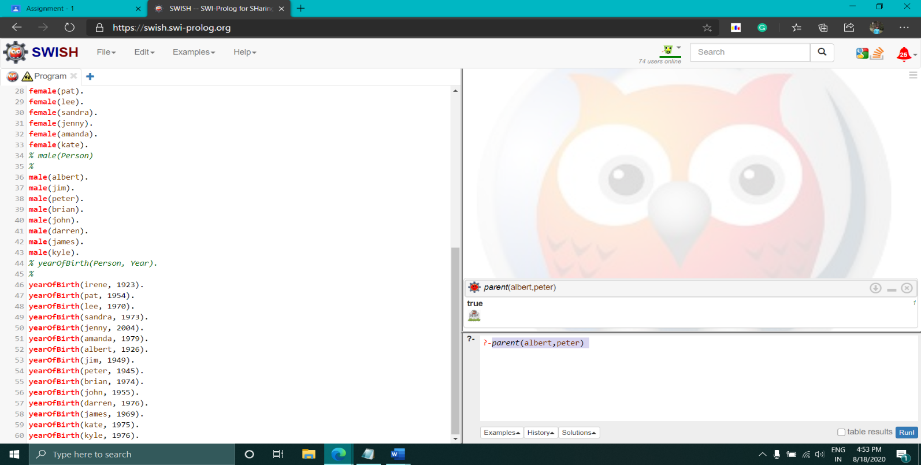

2 findall(X,parent(jim,X),Children).

Output:

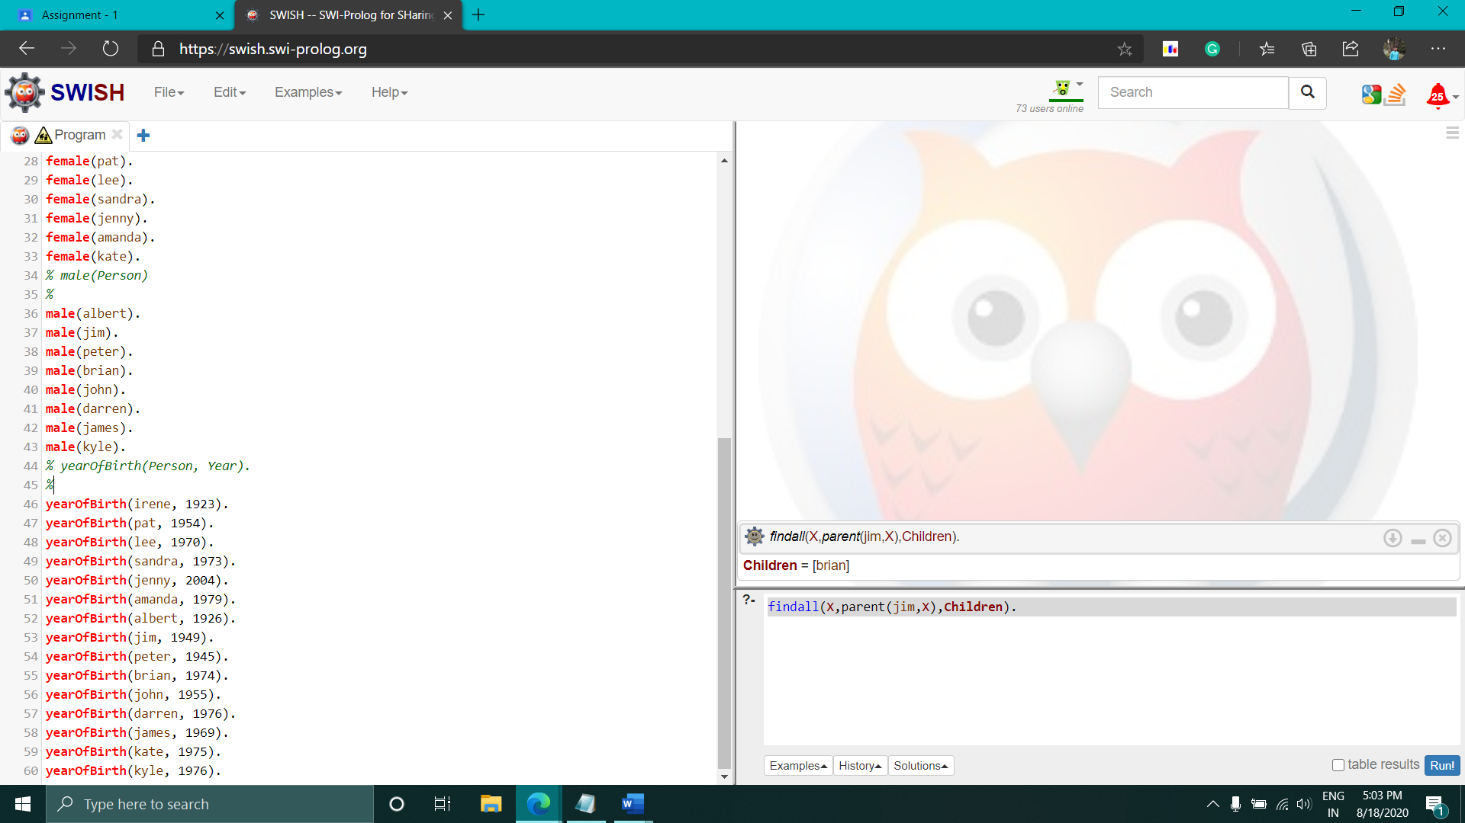

3 findall(X,parent(X,brian),Parent).

Output :

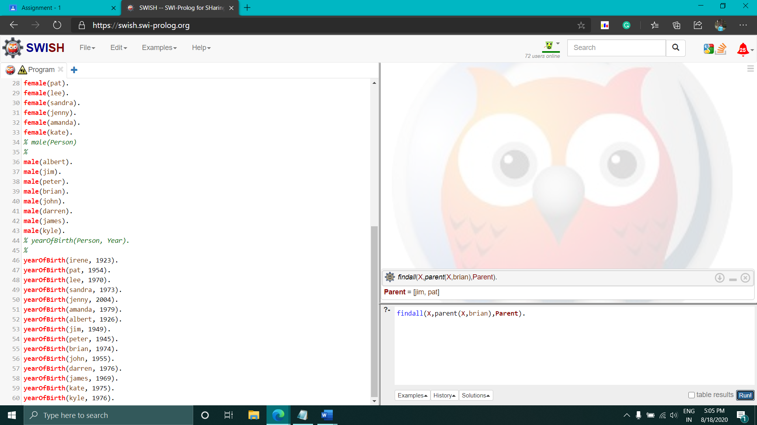

4 First added Function for Grandparent

grandparent(G,P):-

parent(G,X),

parent(X,P).

Then Run : grandparent(irene,brian)

Output:

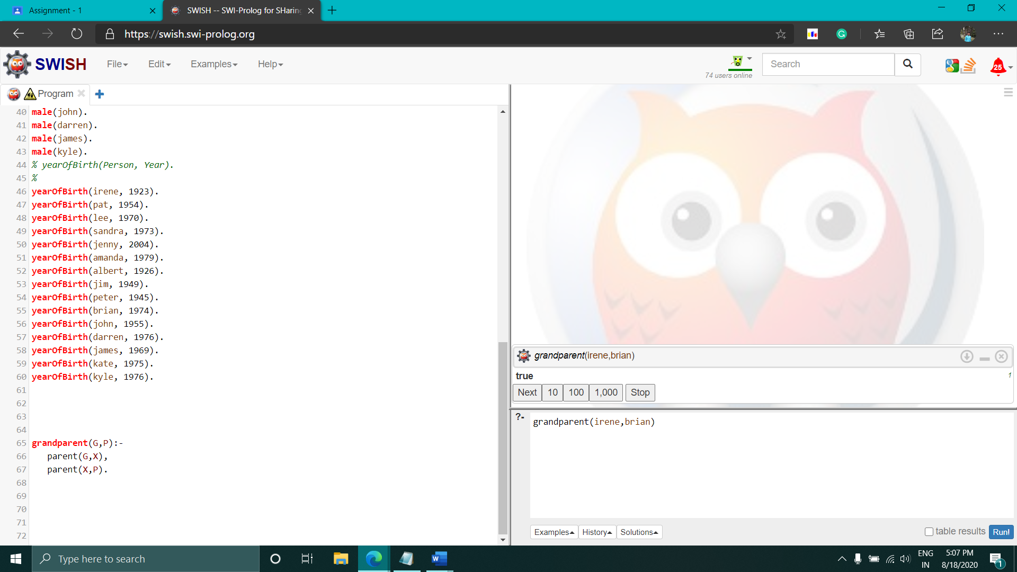

5 findall(Y,(parent(irene,X),parent(X,Y)),Grandchildren).

Output:

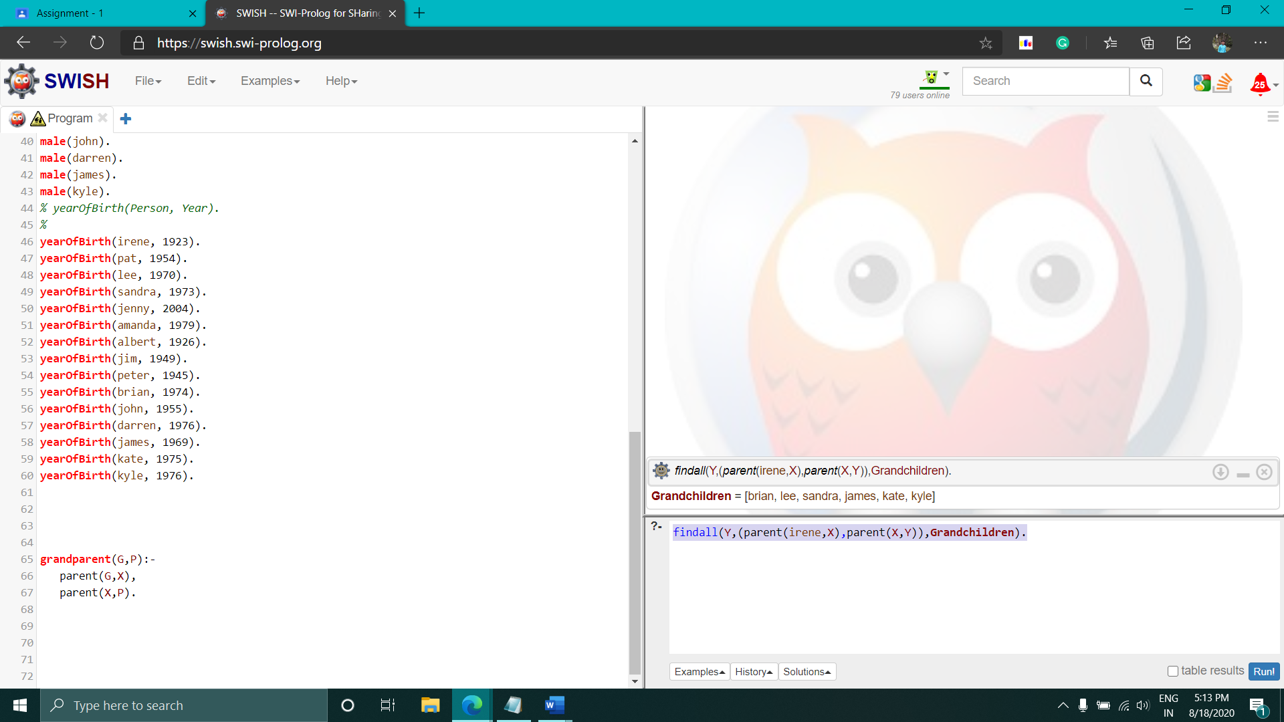

6 Adding this: older(Person1, Person2) :-

yearOfBirth(Person1, Year1),

yearOfBirth(Person2, Year2),

Year2 > Year1.

7 findall(X,older(pat,X),Older).

Output :

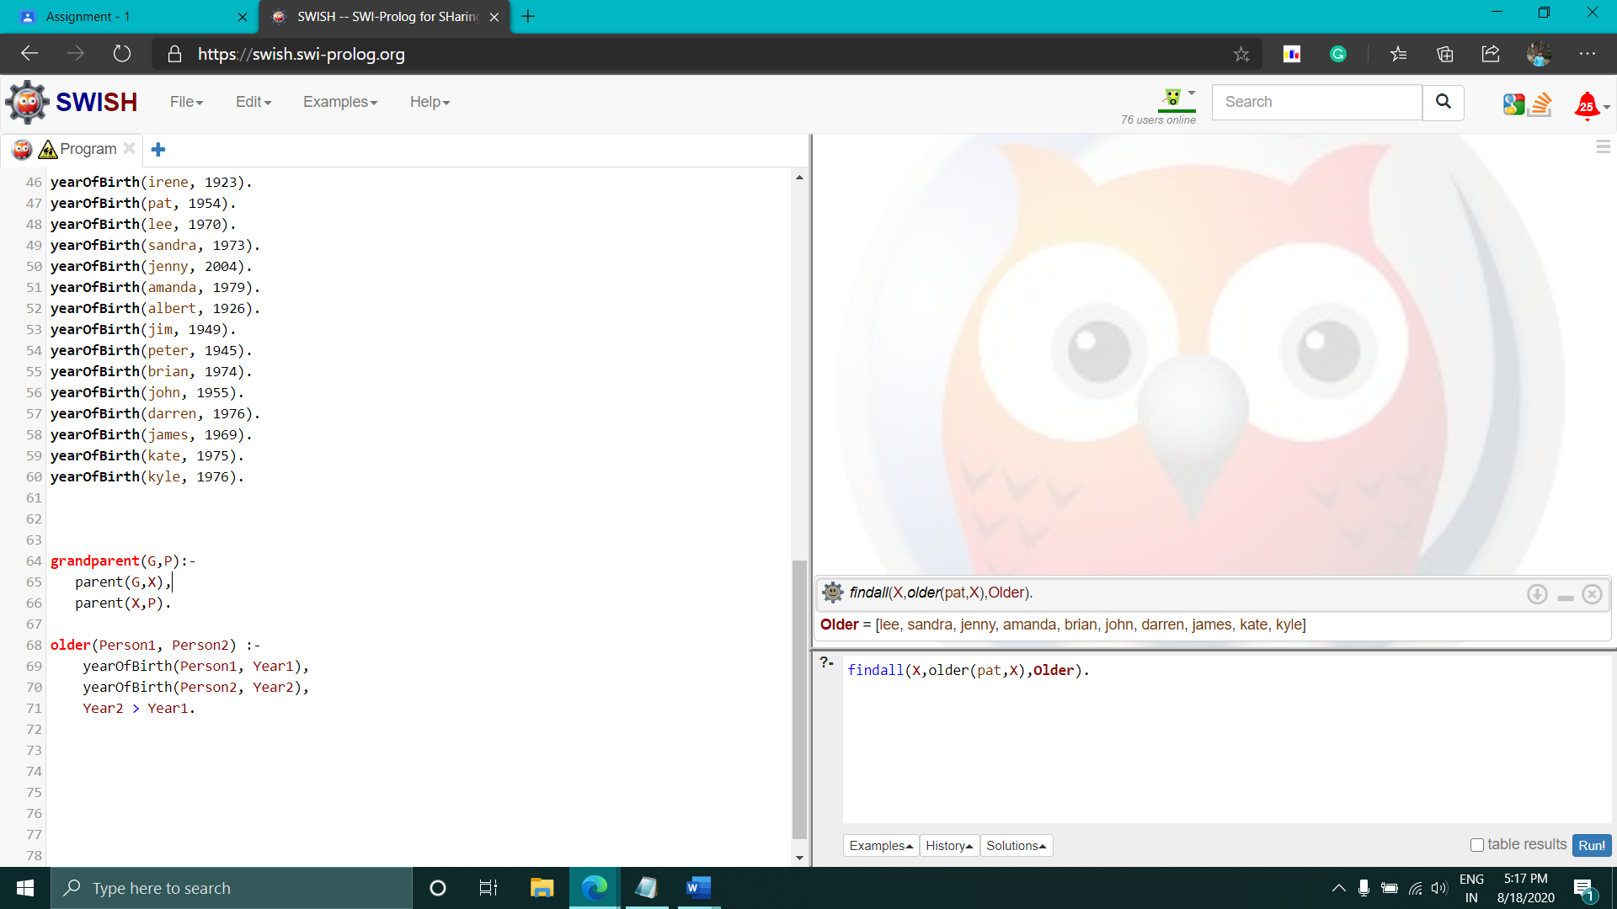

8 findall(X,older(X,darren),Younger).

Output :

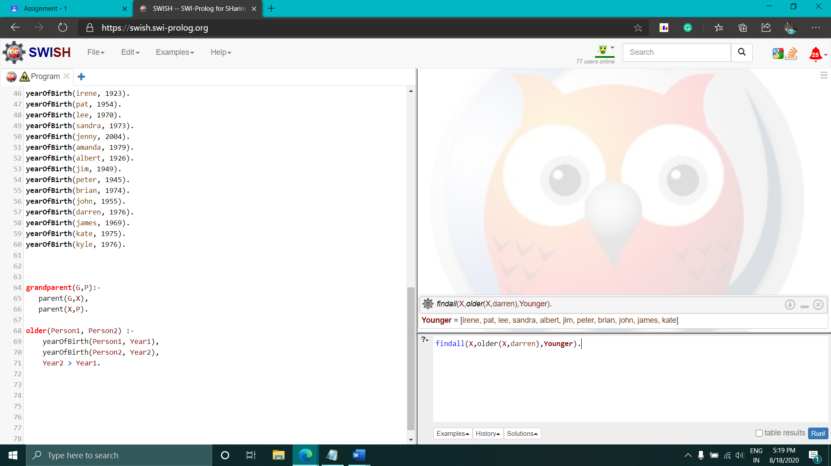

9 findall(Y,(parent(X,sandra),parent(X,Y)),Siblings).

Output :

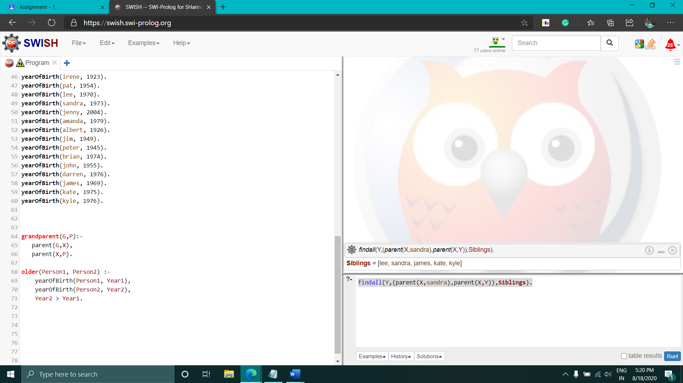

10 Adding this : olderbrother(X,Y):-

male(X),

parent(Z,X),

parent(Z,Y),

X\=Y,

yearOfBirth(X, Year1),

yearOfBirth(Y, Year2),

Year2 > Year1.

Then: olderbrother(X,sandra).

Output :

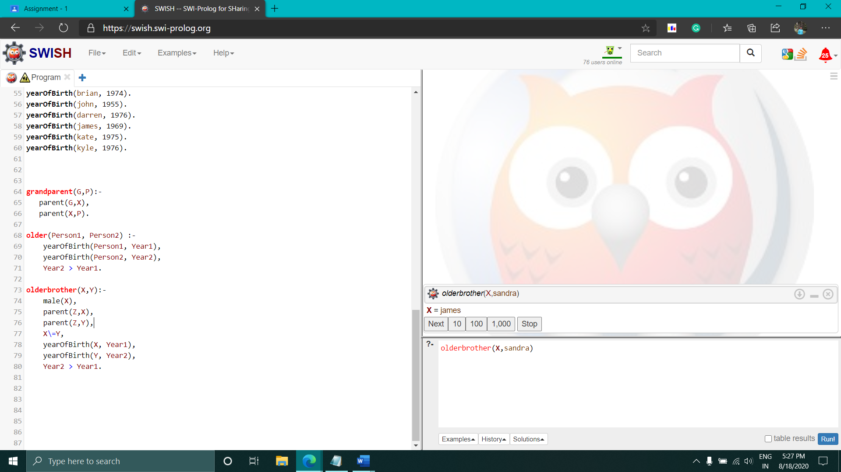

11 Adding this: predecessor(X,Y):-

parent(X,Y).

predecessor(X,Y):-

parent(X,Z),

predecessor(Z,Y).

Then : -predecessor(X,kyle).

Output:

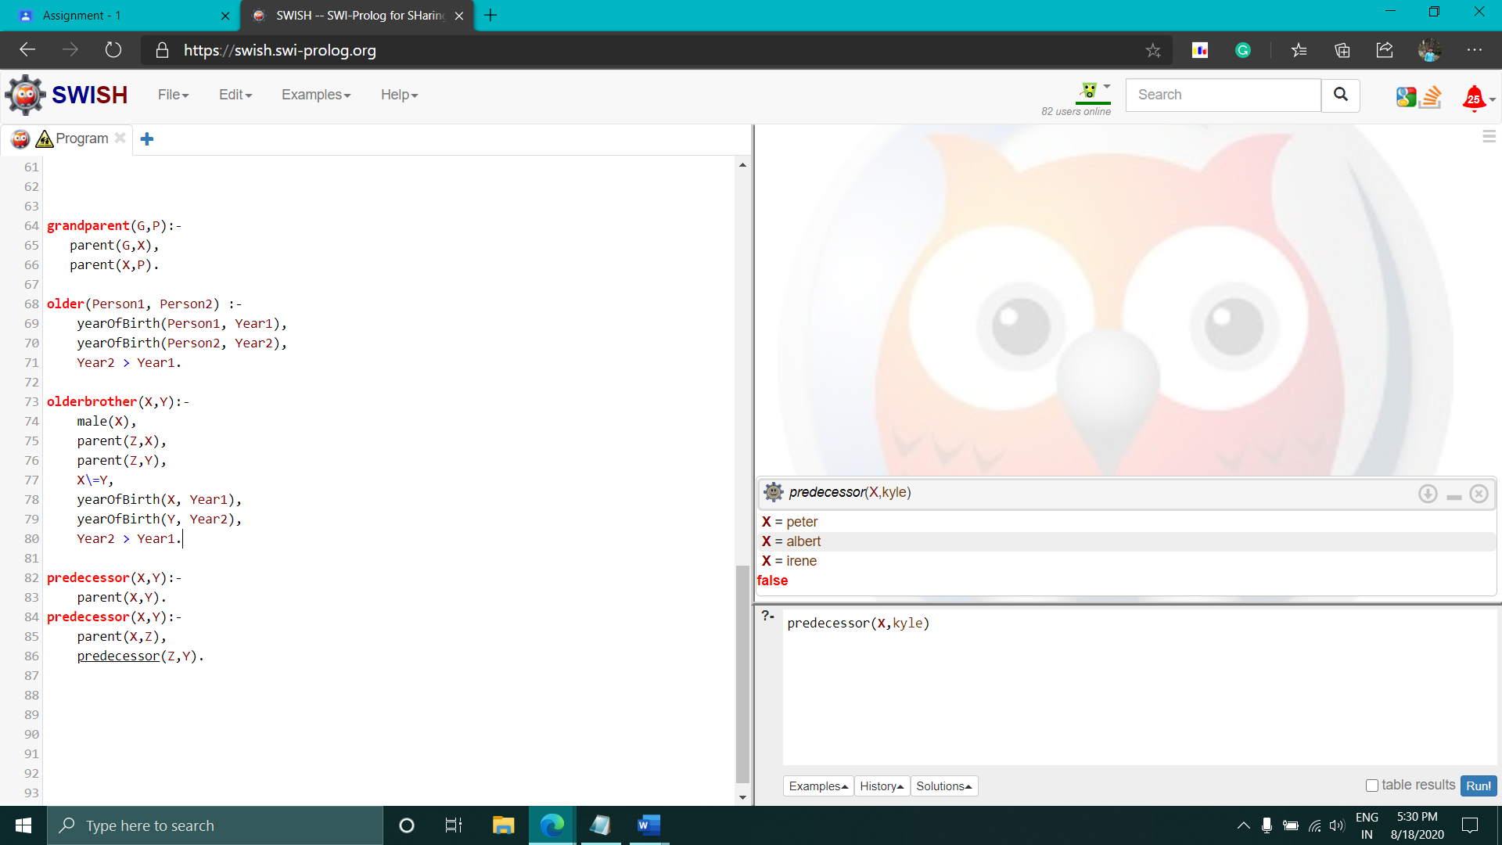

12 Adding this First : sister(X,Y):-

female(X),

parent(Z,X),

parent(Z,Y),

X\=Y.

Then : sister(X,kate).

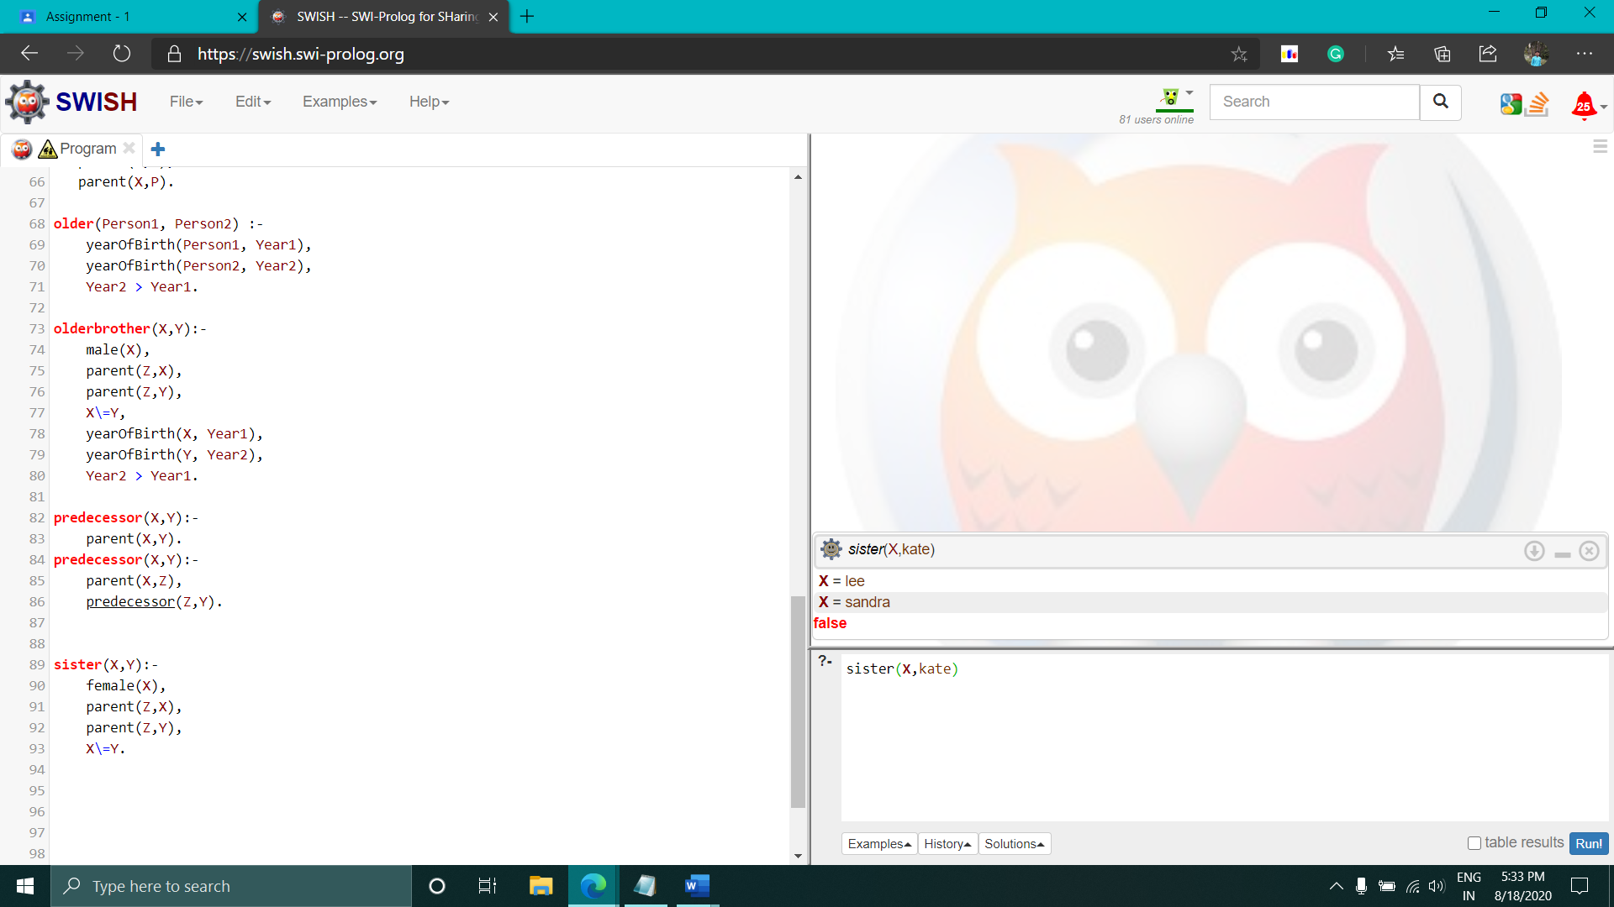

13

1 aggregate_all(count,male(X),Y).

Output :

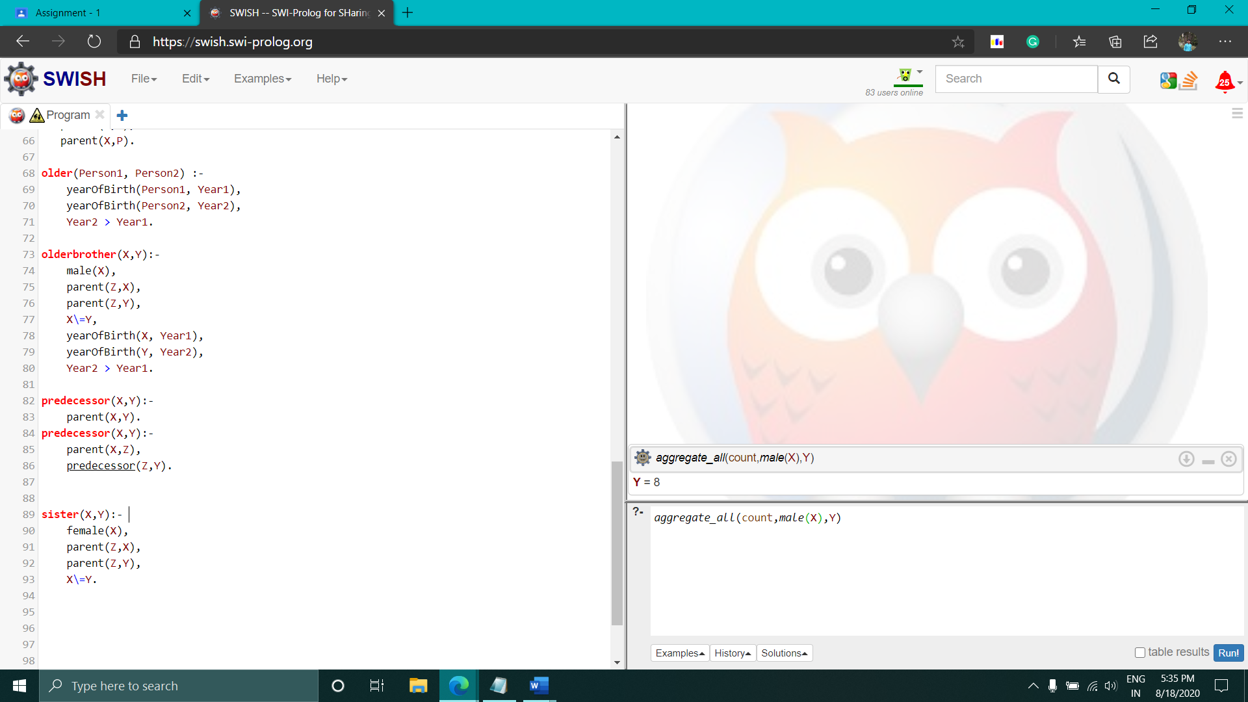

2 aggregate_all(count,female(X),Y).

Output :

